HERITAGE TRUST NORTH WEST
TRUSTEE TERMS OF REFERENCE
AND CODE OF CONDUCT

- About the organisation

Heritage Trust for the North West is a building preservation trust, founded originally in 1978 under a different name, with a long track record of saving important buildings across the North West of England. Over the years we have owned and managed many properties. Currently our portfolio includes approximately 25 buildings spread across twelve sites.
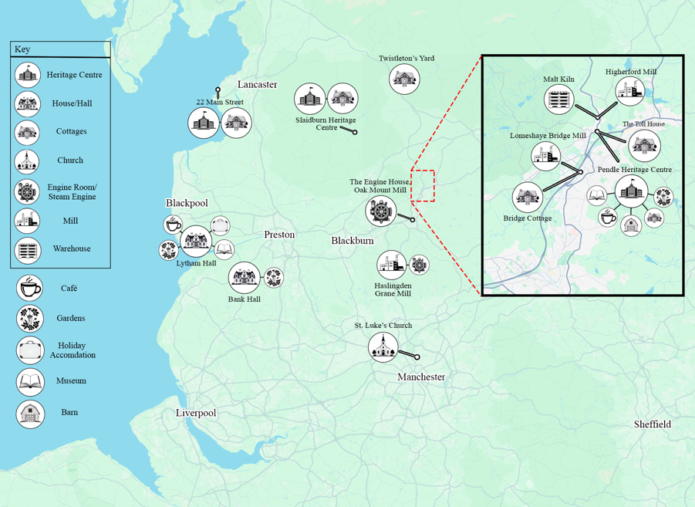
We are a registered charity and company limited by guarantee. The charitable purpose of Heritage Trust for the North West is:
“to promote and preserve for the benefit of the people of the North West of England and of the nation at large, whatever of the English historical, architectural, natural, social or scientific heritage which may exist in or near to the aforesaid region, and to advance the education and the cultural development of the public in these matters, and to undertake such other charitable activities as may benefit the inhabitants of or visitors to the area.”
Our focus is as much on the people using the heritage buildings as the properties themselves. The quality and composition of our heritage projects start from the earlier stages of archaeology, conservation architecture, investigative work, sympathetic building conservation and restoration work. We co-create with communities to establish how our buildings can be run sustainably in the future.

- Governance and Management Structures

HTNW has:

- An experienced, unified and supportive Board of Trustees;
- A Chief Executive with a strong heritage sector track record and wider legal, governance, regeneration and property management skills;
- A core staff team encompassing the management of operations, sites, parkland and volunteers as well as financial and office administration;
- Over fifty staff in total and nearly four hundred volunteers across our sites involved in the following non exhaustive list of activities:
  - grounds and building maintenance;
  - catering;
  - tour guides;
  - archives;
  - administration; and
  - retail.

We also have a wholly owned trading company LHT Enterprises and a small but still effective building repair and management company, Conservation Services North West Limited. These companies are directly managed by the HTNW Chief Executive and Board of Trustees acting as directors.
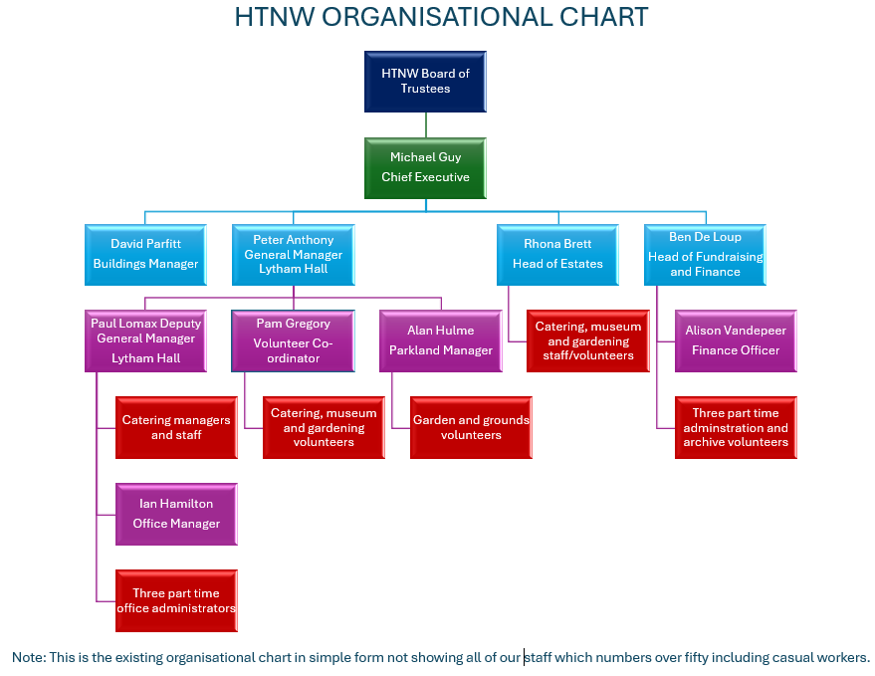

- Board Meetings

Heritage Trust North West is a company limited by guarantee and a charity. It is governed by a Board of Trustees including a Chair, a Vice Chair, a Treasurer and a Secretary. Please refer to the Articles of Association for more detailed rules on the conduct of board meetings.
Meetings are usually held quarterly in February, May, August and November with the final meeting also being our AGM. Most meetings are held in person in the day but some will be online or hybrid and we are open to changing time and location to suit new trustees to ensure maximum participation.

- Roles and Responsibilities

Members of the Board take responsibility for four key areas:
Strategy: The Board sets our vision, values and standards and ensure that its obligations are understood and met. The Board also sets the strategic aims and ensure that the necessary human and financial resources are in place for the organisation to meet its objectives.
Performance: The Board scrutinises the performance of Chief Executive and staff team in meeting agreed goals and objectives and monitor the reporting of performance.
Risk: The Board provides leadership of the organisation within a framework of effective controls, which enable risk to be assessed and managed. All Board members should satisfy themselves on the integrity of financial information and that financial controls and systems of risk management are robust and defensible.
People: The Board are aware of the interests of all our stakeholders such as partners and funders. They have a prime role in appointing and reviewing the performance of the Chief Executive but also other senior staff and fellow trustees. They have a general responsibility for the welfare of all our staff and volunteers ensuring that good practice and a framework of appropriate polices are in place and adhered to.

- Role of the Chair

The Chair is appointed by the Board to act as Chair of the Board, Chair of the Annual General Meeting and any other General Meetings of the organisation. They have a casting vote at meetings where they are in the Chair.
Specific responsibilities include:
- Ensure the proper conduct of all Board business.
- Ensure probity and integrity of the Board.
- Approve Board Agendas.
- Take part in, or approve processes for, selection and appointment of Trustees.
- Establish, maintain and develop reporting and meeting procedures for the Board and its Committees if any.
- Ensure the Board assign appropriate tasks and objectives to individual members and agree the working and reporting relationships.
- Ensure the Board receives the timely information it needs.
- Maintain proper focus on the Board’s key role and tasks.
- Keep meetings to time, allowing opportunity for important matters to be discussed thoroughly.
- Encourage and ensure all trustees make a full contribution.
- Draw together pertinent points to reach well informed consensus.
- Ensure adequate minutes are kept and agreed actions completed.
- Review and monitor the Board’s effectiveness and conduct an annual performance appraisal of the Board and the members of the Board by having at least annual one to one conversations with each member at a dedicated private meeting.
- Review and monitor the performance of the Chief Executive as required by the Board.
- Effectively manage any conflicts of interest.
The Board may appoint a Vice Chair and if they do so that person also assumes the responsibilities listed above if the Chair is not able to complete them for any reason.

- Board sub committees

The Board is able to appoint sub-committees and working groups and delegate decision making powers to them but we do not currently have any.

- Trustees Conduct

All trustees are expected to conduct themselves in a manner that reflects positively on themselves and the organisation and not to conduct themselves in any way that could reasonably be regarded as bringing their office or the organisation into disrepute. The Nolan Principles and the Charity Commission guidance sets the standard and these should be read and understood by all trustees and followed at all times.
https://www.gov.uk/government/publications/the-7-principles-of-public-life
https://www.gov.uk/government/publications/the-essential-trustee-what-you-need-to-know-cc3
Specifically, trustees must:
- Respond promptly to all communications requiring a response, such as meeting requests or decisions in between meetings.
- Attend meetings and other appointments or give their apologies. A poor record of attendance should be addressed by the Chair if it arises or by the Vice Chair or Board if it is the Chair themselves whose attendance is below expectations.
- Prepare fully for meetings and all work for the organisation, reading papers, querying anything not understood and thinking through issues in good time before meetings.
- Actively engage in discussions, debate and voting in meetings when requested.
- Act in the best interests of the organisation at all times.
- Be loyal, ethical, honest and act with integrity and probity.
- Adhere to the organisation’s values and support the Chair and Chief Executive in instilling the appropriate culture, values and behaviours in the boardroom and beyond.
- Respect others and treat them with dignity and fairness.
- Respect confidentiality, GDPR and data protection, understanding what this means in practice for the organisation, its board and the individuals involved with it.
- Have a sound and up-to-date knowledge of the organisation and its environment.
- Seek to ensure that no one is unlawfully discriminated against and promote equal opportunities and social inclusion in accordance with the organisation’s policies, best practice and the law.
- Recognise that the Board is collectively responsible for the exercise of its powers and the performance of the organisation.
- Raise concerns and provide constructive challenge regarding the management and operation of the organisation, where appropriate.
- Take and consider advice on issues where appropriate.
- Not use their position for personal advantage or seek to gain preferential treatment for themselves, their family or their friends, nor seek improperly to confer disadvantage on any other person.
- Not place themselves under any financial or other obligation to outside individuals or organisations that might seek to influence them in the performance of their Board duties.
- Accept responsibility for their own performance, learning and development.

- Fit and proper person

All Trustees are required to complete and comply with the Charity Commission’s ‘Charity trustee: declaration of eligibility and responsibility’. Trustees must certify on appointment, and upon each term reappointment, that they are/remain a fit and proper person.
If circumstances change so that a Trustees can no longer be regarded as a fit and proper person or if it comes to light that a Trustee is not a fit and proper person, they will be suspended from being a Trustee with immediate effect pending confirmation and any appeal. Where it is confirmed that a Trustee is no longer a fit and proper person, their position as a Trustee will be terminated.

- Conflicts of interest

Trustees have a duty to avoid a situation in which they have or could have a direct or indirect interest that conflicts (or possibly may conflict) with the interests of the organisation. Trustees have a further duty not to accept a benefit from a third party by reason of being a Trustee or doing (or not doing) anything in that capacity.
Trustees are required to record all relevant interests in the minutes of the Board meetings or in a register of interests if one is necessary. It is the responsibility of each trustee to provide an update if their interests change.
If a trustee has, in any way, a direct or indirect interest in a proposed transaction or arrangement with the organisation, the trustee must declare the nature and extent of that interest to the other trustees at the earliest opportunity. If such a declaration proves to be, or becomes, inaccurate or incomplete, a further declaration must be made. Any such declaration must be made as soon as possible and before the organisation enters into the transaction or arrangement.
The Chair or Chief Executive will advise trustees in respect of any conflicts of interest that arise during Board meetings, including whether the interest is such that the trustee should withdraw from the meeting for the period of the discussion. In the event of disagreement, it is for the Board to decide whether a Trustee must withdraw from the meeting.

- Gifts and hospitality

The Board will set an example in the use of its funds and the need for good value, particularly with respect to public funds and donations, when incurring expenditure. The use of the organisation funds for hospitality and entertainment will be carefully considered. All expenditure on these items should be transparent and capable of justification in light of the organisation’s charitable and business objectives.

- Expenses and renumeration

The trustees, upon request, may be paid all reasonable travelling, hotel and other expenses properly incurred by them in connection with their attendance at meetings of trustees or committees of trustees or general meetings or otherwise in connection with the discharge of their duties, but shall otherwise be paid no remuneration.

- Appointment and term of office

Trustees are usually appointed to the annual AGM by voting to approve the appointments. Trustees may be co-opted onto the Board at other times of the year with approval of the Board.

Trustees shall serve for a term of three years from appointment unless terminated or they resign. Two consecutive terms of service may be served. Any additional consecutive terms of service must be approved unanimously by the Board.

- Breach of the code

A reported breach or suspected breach of this code of conduct will result in an investigation being undertaken by the Chair, or their nominated representative. Serious breaches will result in termination of the Trustee’s appointment in accordance with the Articles of Association.
In the unlikely event of an unresolved dispute between a Trustee and the organisation over the decision to terminate their appointment due to a breach of this code the trustee may appeal by setting out in writing to the Chair the reasons for their appeal. The organisation will utilise the services of an independent dispute resolution service for the appeal and the trustee raising the appeal may be required to contribute towards the cost of this. In the event of the appeal being found in favour of the trustee, the financial contribution will be returned in full.

This document was approved by Board on [ ] May 2025. It is to be reviewed on a biannual basis.

